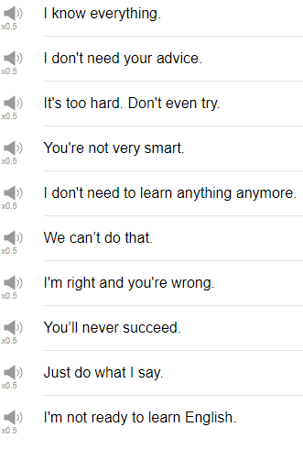

|  |
| --- |
| Here I go, here I go, here I go! |
| Hi, everybody! My name is Alisha, welcome back to Top Words. Today we're going to be talking about 10 Phrases that Make You Look Like a Fool. Hopefully you never use them, let's start! |
| 1. I don't need to learn anything anymore. |
| If you say this, you sound like I know all the information ever, I'm done learning, i'm done studying. Of course you need to learn, of course you need to study. please don't say this phrase. |
| 2. I don't need your advice. |
| You sound like you don't appreciate what they're saying, you sound like you don't want to hear anything from them. "I really think that you need to be studying or I'm concerned about your grades, Jeff." Who need your advice, mom? |
| 3. I know everything. |
| This is awful! Nobody wants to hear you say this, because it's just not true! "Are you ready for the test next week, Steve? ""Yeah, I'm good, I know everything.""" No, you don't. |
| 4. I'm not ready to learn English. |
| Hmm… You can study anything in any time, pretty much. "I really think that you should start studying English before your trip to America next year." "mm... no I don't think I'm ready to start learning English. See how stupid that" sounds! |
| 5. I'm right and you're wrong. |
| You sound awful when you say this, nobody likes to hear that. They've made a mistake and that you're happy about that, that's what the nuance of this phrase is. I'm right you're wrong, don't say this phrase unless you're very very close with the other person, and you know that it's okay to joke together. I'm right you're wrong, haha. |
| 6. It's too hard, don't even try. |
| This sounds like you've given up before you've even started doing something, if you don't try you never know, right? Don't even try, it's way too hard. "Oh really? You think it's too hard? Hmm... okay i guess i won't. Don't do that!" |
| 7. Just do what I say. |
| Parents might use this phrase a lot with their children actually, but if you say this to your friends or to your colleagues, you're going to sound like a really mean or difficult-to-work-with person. Just do what I say. |
| 8. We can't do that. |
| The next phrase is "we can't do that". This could also be changed to "I can't do that". Again, that sounds like you're giving up before you even try to do something. I can't do that. You're just, you're not prepared, or you're not even willing to try. Ah no, i don't think i can do that. No, that's not my job, that's not my responsibility. |
| 9. You're not very smart. |
| That's not a nice thing to say! If someone makes a mistake and you say oh, you're not very smart, that's so mean! It's so rude! Everybody makes mistakes from time to time, don't tell them they're stupid, don't say you're not very smart, that's hurtful. An example of what not to do: "I'm so so sorry about this mistake that I made in my report last week. I'll fix it, I promise I'll fix it and i'll send it to you right away." "I can't believe you made such a simple mistake, you're not very smart, are you?" Everybody makes mistakes. |
| 10. You'll never succeed. |
| This is a phrase that shows you're not supporting the other person, and maybe you're even trying to hold them back, how awful is that! Who would say that? Don't say that! And I hope no one ever says this to you. going to succeed with that! Do you know how hard those are? Have you even started training?" "Well, no, but I i think i can do it! I just need a few months, and you know I need to take care of myself and work hard." "No way!There's no way that you can do that, it's not possible." "Oh! You really think so? I was so looking forward to it too..." |
| Thank goodness that's the end! Oh my gosh! Those were some sad phrases! I hope that nobody says those phrases to you! But I hope also that you don't use these phrases with other people, because they're hurtful, really! Try to be positive! So thanks very much for joining us for this lesson, and we will see you again soon. Bye! |
| I'm very insecure about my acting abilities. There's sound coming through this. I love the awkward pauses! |